**Day 2 Hackathon**

**Planning Technical Foundation**

**Submission Title:**

**“Marketplace Technical Foundation [ Saima Ecommerce]”**

1. Define Technical Requirement

**Frontend website:**

* User friendly interface
* Make sure it is responsive on mobile and other devices

**Sanity CMS as back-end:**

* User sanity CMS to manage product data customer details, order details & record
* Designing schemas in sanity

**Third party API’s:**

* User APIs for shipment tracking payment method

2. Design System Architecture

[

Frontend (Next.js)]

Sanity CMS -------> [Product Data API]

Third-Party API --------> [Shipment Tracking API]

[Payment Gateway]

Key Workflows to Include:

1. User Registration:

The user signs the website

2. Product Browsing:

User browse through various product as they click on any product to visit its detail page, which is powered by sanity as the backend CMS for updating product details.

3. Adding to cart:

user add the desired products in the cart.

4. Payment method:

User proceed to the payment page where they can choose payment method including cash on delivery, credit cards and online platforms.

5. Shipment:

After the payment, the shipping process is handled by ShipEngine, which track the delivery from the warehouse to the customer’s address.

Home

Login

Product category Page

Products Detail

Add To Cart

Payment Method

Checkout

Shipment Process

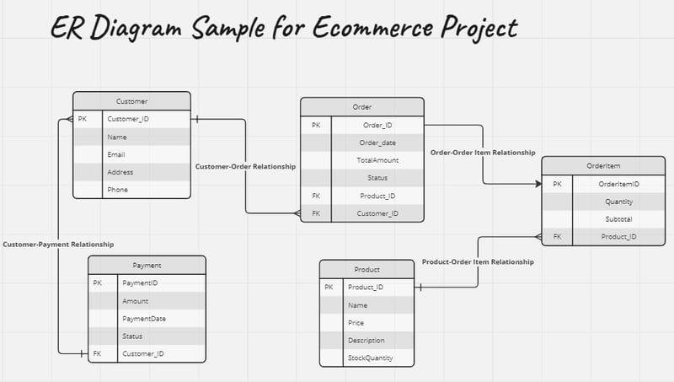

3. Plan API Requirements

|  |  |  |  |  |
| --- | --- | --- | --- | --- |
| **End Point** | **Methods** | **Description** | **Parameters** | **Response Example** |
| /api/products | GET | Fetch All products | - |  |
| /api/product/id | GET | Fetch Single product | Path id | {id:,name} |
| /api/Cart/Category | POST | Add an item | Name,Price,Category | {success:true,id:5} |
| /api/product/id | PUT | Update an item | Id,name,price | {success:true,id:5} |
| /api/Products/id | DELETE | Delete an item | id | {success:true} |

Sanity Schema for website

export default {

name: 'product',

title: 'Product',

type: 'document',

fields: [

{

name: 'name',

title: 'Name',

type: 'string',

},

{

name: 'description',

title: 'Description',

type: 'text',

},

{

name: 'category',

title: 'Category',

type: 'reference',

},

{

name: 'price',

title: 'Price',

type: 'number', },

{

name: 'stock',

title: 'Stock',

type: 'number',

},

{

name: 'image',

title: 'Image',

type: 'image',

},

],

};

export default {

name: 'category',

title: 'Category',

type: 'document',

fields: [

{

name: 'name',

title: 'Name',

type: 'string',

},

## Category Schema

{

name: 'description',

title: 'Description',

type: 'text',

},

],

};

## User Schema

export default {

name: 'user',

title: 'User',

type: 'document',

fields: [

{

name: 'username',

title: 'Username',

type: 'string',

},

{

name: 'email',

title: 'Email',

type: 'string',

},

{

name: 'password',

title: 'Password',

type: 'string',

},

],

};

## Order Schema

export default {

name: 'order',

title: 'Order',

type: 'document',

fields: [

{

name: 'user',

title: 'User',

type: 'reference',

},

{

name: 'totalAmount',

title: 'Total Amount',

type: 'number',

},

{

name: 'paymentMethod',

title: 'Payment Method',

type: 'string',

options: {

list: [

{ title: 'Credit Card', value: 'credit_card' },

{ title: 'PayPal', value: 'paypal' },

{ title: 'Cash on Delivery', value: 'cash_on_delivery' },

],

},

},

{

name: 'shippingAddress',

title: 'Shipping Address',

type: 'text',

},

{

name: 'orderStatus',

title: 'Order Status',

type: 'string',

options: {

list: [

{ title: 'Pending', value: 'pending' },

{ title: 'Shipped', value: 'shipped' },

{ title: 'Delivered', value: 'delivered' },

{ title: 'Cancelled', value: 'cancelled' },

],

},

},

],

};

## Order Item Schema

export default {

name: 'orderItem',

title: 'Order Item',

type: 'document',

fields: [

{

name: 'product',

title: 'Product',

type: 'reference',

},

{

name: 'quantity',

title: 'Quantity',

type: 'number',

},

{

name: 'price',

title: 'Price',

type: 'number',

},

{

name: 'total',

title: 'Total',

type: 'number',

},

],

};